Project Concept Document

Project Number | 43
Project Title | Porting of Circular Dichroism Spectroscopy to JavaScript
Document | DASS Project Concept Document
Creation Date | January 21, 2020
Created By | Naren Akash R J
 | Jalees Jahanzaib
 | Mayank Goyal
 | Meena Raja Sree
Client | Mrs. Padmapriya Raman
 | Virtual Labs

Description

Virtual Labs is an initiative of MHRD, Government of India to provide remote experimentation facilities to students, faculty members of higher education institutes and researchers who do not have access to good lab facilities. This project consists of over 100 virtual labs with more than 1500 web-enabled experiments which are designed for remote operation. The experiments and activities are created through embedded SWF files. The browsers do not natively support Flash and we had to download the Flash plugin. SEO and accessibility of data from the SWF file also posed a variety of problems. In today’s scenario, HTML, CSS and JavaScript combination is the most-widely used web tool. The DASS project focuses on porting the Circular Dichroism

Spectroscopy lab from Flash to JavaScript.

Profile of Users

The primary target audiences are students and faculty members of science and engineering colleges who do not have access to good lab facilities. Highly motivated high-school students, researchers from various educational institutes, and different educational institutes may use the resources available for learning, teaching and collaborating. A great majority of the audience are assumed to be computer-literates.

Usage Model and Diagrams (if any)
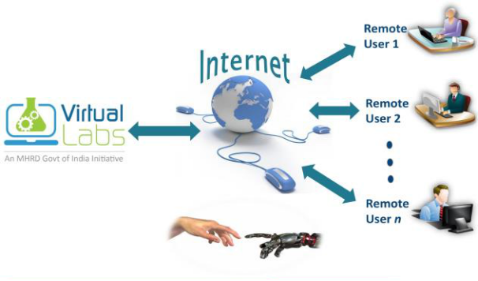

The lab consisting of simulation-based experiments do not need additional infrastructure for conducting experiments at user premises. A computer/mobile phone with internet connectivity is enough for accessing the labs.

